Social and Cultural Differences between Regions in Belgium
Coursera – IBM Data Science – Capstone project

Table of Contents

1 Introduction 3
1.1 Business understanding 3
1.2 Approach 3
2 Data acquisition and cleaning 4
2.1 Belgian cities data 4
2.2 Location of the cities 4
2.3 Names of the cities in the three country-languages 5
2.4 City venues data 6
2.5 Geojson file containing the Belgian city borders 8

Introduction

Business understanding
Belgium is a small country in central Europe with approx. 11 million habitants. The capital of Belgium is Brussels, which is also the capital of Europe.
Despite having merely the size of a big city, Belgium is a divided country. There are three communities: a French-speaking community in the South (approx. 4 million), a Dutch-speaking community in the North (approx. 7 million), and a very small German-speaking community.
The fact that there is a political difference is proven with each election. Most people also live with the idea that there are also social and cultural differences, but hard proof is not immediately available.
Many companies – especially the multi-nationals located in Brussels – are working with a mix of employees from both parts of the country. Those companies already found a way to deal with the language difference, but the HR departments of those companies would also want to work with the cultural and differences – if they exist.
The hypothesis that we want to validate:
There are important social and cultural differences between northern (Dutch-speaking) and southern (French-speaking) cities in Belgium.

Approach
We believe that a natural way to characterize a city - and the people that live in that city - is by the popularity of its venues. For example by tallying the amount of parks, bars, restaurants or universities it has relative to all other types of venues, one can get a sense of the cultural and social character of a city.
Therefore, if we could lay our hands on data w.r.t. what the popular venues are in each city, we could use clustering techniques to classify cities into categories. These categories can then be visualised on a map to get an idea about the geographical dispersion of the categories. If there is a difference between categories mainly appearing in the south and categories mainly appearing in the north, we have proven our hypothesis.

Data acquisition and cleaning

Belgian cities data
The first dataset that we use is a table that is published on the Dutch Wikipedia that gives an overview of the cities in Belgium with some key metadata.
https://nl.wikipedia.org/wiki/Tabel_van_Belgische_gemeenten
The columns of this table that we are using:
- Name of the city (Gemeente)
- Number of habitants in 2019 (2019 index)
- Acreage of the city (Opp. km²)
- Habitants per km² (inw. per km²)
- Prosperity index (2016 Welv.-index)
- The province to which the city belongs (Provincie of gewest)
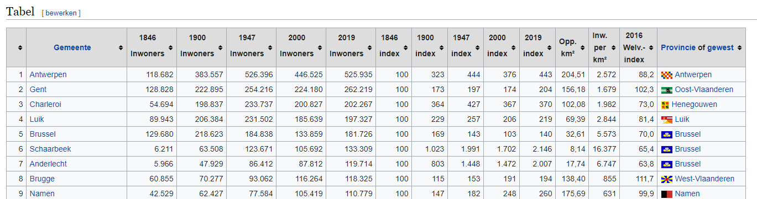
This HTML table is parsed using the beautifulsoup4 Pyhton package, which is aimed at ‘screen-scraping’ online HTML documents. The next figure illustrates the resulting pandas dataframe.
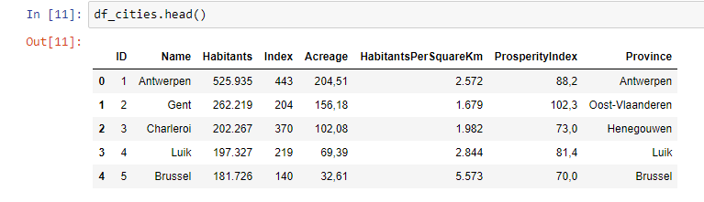
Remark: The Name field contains the Dutch name of the city!

Location of the cities
In order to visualize the cities on a map of Belgium we need their geo-location (latitude-longitude). This location can be retrieved using the geopy package in Python. The resulting pandas dataframe is shown in the following picture.
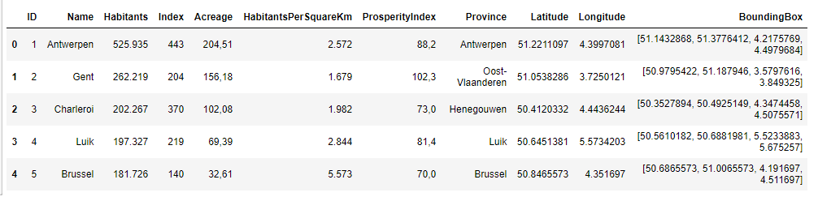

Names of the cities in the three country-languages
Many cities in Belgium have different names in the different languages. The following file that is published by the federal government contains the city names for the three languages.
https://economie.fgov.be/sites/default/files/Files/Entreprises/KBO/KBO-codes-identificatie.xls
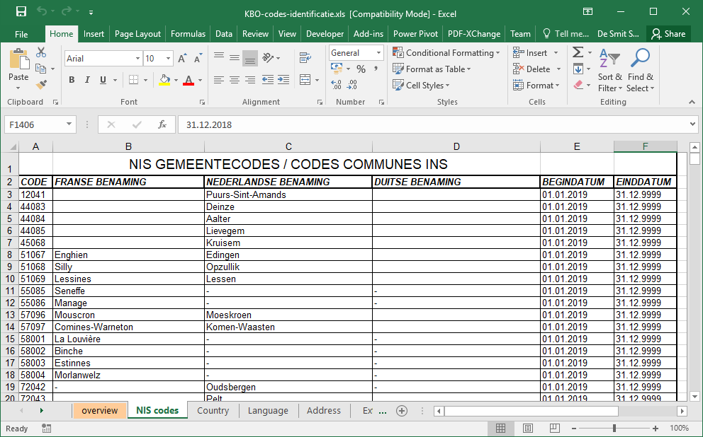
This file can easily be read and stored in a dataframe using standard pandas features (pd.read_excel). This is the resulting pandas dataframe:
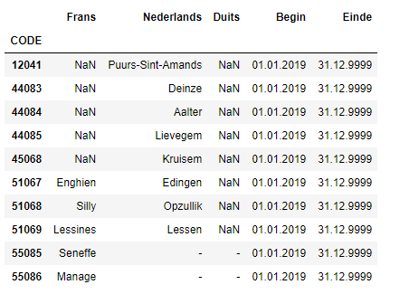

City venues data
A good source of information for venues all over the world is Foursquare. Foursquare offers a Places API to gain real-time access to Foursquare’s global database of rich venue data and user content. One can easily find popular venues in a city or a location by using the explore function in the Place API.
Remark: You have to register to get a client_id and secret to be able to access that API. By using the free subscription you can make a limited number of API calls per day.
GET https://api.foursquare.com/v2/venues/explore
You can simply pass the following URL parameters
client_id and client_secret | These are your credentials that you receive when you subscribe to the API and that you need to pass with each API call.
v | The version of the API that you want to access.  e.g. ‘20180605’
near | The location that you want the venues for.  e.g. ‘Lokeren, Belgium’
radius | Radius to search within, in meters. If radius is not specified, a suggested radius will be used based on the density of venues in the area.  e.g. ‘2000’ (2 km’s)
limit | Number of results to return, up to 100.
and what you get back as a result is a list of venues in a JSON format.
The following extract of a result message gives you an idea about the venue data this is returned.
{'reasons': {'count': 0,
'items': [{'summary': 'This spot is popular',
'type': 'general',
'reasonName': 'globalInteractionReason'}]},
'venue': {'id': '4c5093d9bd099521bed1525e',
'name': 'De Donkere Wolk',
'location': {'address': 'Torenstraat 14',
'lat': 51.105140425790516,
'lng': 3.991317566213707,
'labeledLatLngs': [{'label': 'display',
'lat': 51.105140425790516,
'lng': 3.991317566213707}],
'postalCode': '9160',
'cc': 'BE',
'city': 'Lokeren',
'state': 'Oost-Vlaanderen',
'country': 'België',
'formattedAddress': ['Torenstraat 14', '9160 Lokeren', 'België']},
'categories': [{'id': '4bf58dd8d48988d116941735',
'name': 'Bar',
'pluralName': 'Bars',
'shortName': 'Bar',
'icon': {'prefix': 'https://ss3.4sqi.net/img/categories_v2/nightlife/pub_',
'suffix': '.png'},
'primary': True}],
'photos': {'count': 0, 'groups': []}},
'referralId': 'e-0-4c5093d9bd099521bed1525e-0'}
This JSON file can easily be parsed and stored in Python dictionary data structure. The data from that dictionary can then be stored in a pandas dataframe.
We can do that for each city in the dataframe that holds the complete list of all Belgian cities (see section 2.1). The resulting dataframe looks like:
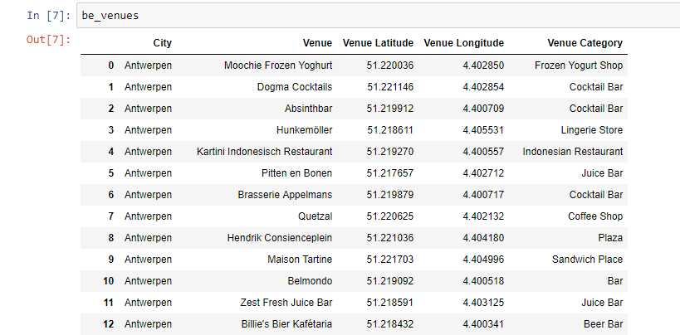

Geojson file containing the Belgian city borders
In order to visualize our results in a Folium choropleth, we need a geo-json file containing the location data for the city borders. We found one in GitHub. It’s not a very recent one, but it will do the trick for this project.
https://github.com/Datafable/rolling-blackout-belgium/blob/master/data/geospatial/municipalities-belgium.geojson
Remark: For cities that are officially bilingual a somewhat special format is used in this file:
- dutchname#frenchname when the primary language is Dutch - e.g. Brussel#Bruxelles
- frenchname#dutchname when the primary language is French - e.g. Enghien#Edingen
We need to have that special name in our input dataset, so that the city can be mapped on the location in the geojson file.

